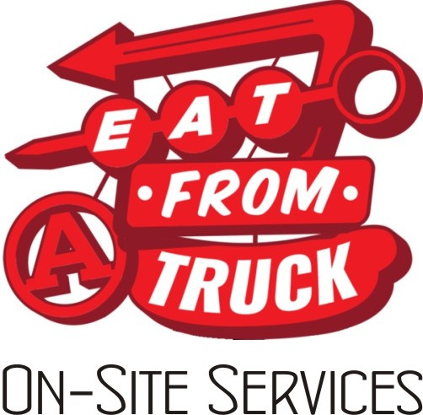

Request for Service

Date of Service _____________ Company __________________________________________________

Contact Name(s) ___________________________________________________________________________

Office Phone Number _____________________________ Day of Event Phone _______________________

Street Address __________________________________________________________ Suite #____________

City, State, Zip ____________________________________________________________________________

Choose Your Service: _____ I want a specific truck, and that truck is _________________________________
Here are my date availabilities:
My first choice of dates is ________________________

My second choice of dates is ________________________

My third choice of dates is _______________________
OR

_____ I want a specific date, and that date is _____________________________
I am interested in any of the following trucks:
My first choice of trucks is _______________________

My second choice of trucks is ________________________

My third choice of trucks is ________________________

I would like to book the truck: _____from 11am-1 _____from 12 noon- 2pm _____other: ______* (write in)

I would like to book __________ (number of) lunches.

*We will be happy to consider other time periods if neither of these works for you. Larger parties may require a longer serving period; the truck will determine the length of time required and then we will work out the final hours of service with you. With a minimum of 50 guests, you will receive a two-hour standard serving window.

Eat From A Truck On-Site Services/Request For Service, page 2

Eat From A Truck On-Site Services Program Specifics:

~ The minimum number of guests allowed to participate in this program is 50; you may book as many guests as you need to beyond 50.

~ Your bill will be calculated using a cost of $10 per person. Applicable taxes will be added to that amount.

~ Payment is due in full via PayPal at the time of confirmation and booking, and at least two weeks before the
event date.

~ You may cancel your event up to two weeks before the scheduled date in order to receive a refund; after that time, refunds will not be issued.*

~ If the company needs to make a change to their contract date, they must do so at least two weeks before
the scheduled date. A change in date must be agreed upon by both parties. If a mutually agreeable date
is unavailable, the company may choose to schedule another truck instead, if one is available. Date
change requests with less than two weeks’ notice might not be able to be accommodated, and no refund
will be given.*

~ A minor change to the number of participants (up to 10% variance) may be made up to 72 hours before
the scheduled visit; however, the total number of guests cannot drop below 50. A major change in
number (10%+) needs to be made at least one week in advance.

~ You will receive numbered tickets specifically for your event, to be distributed as needed. Each ticket may
only be printed and used once, and will be redeemed at the truck for the meal.

~ No lunch will be served without this ticket; additional lunches will not be available for purchase at
the event. Additional beverages may be available for purchase.

~ Sometimes trucks break down and cannot meet their obligations. If the contracted truck cannot visit
as scheduled, we will try to offer an alternate truck. This is not always possible, due to the last minute
nature of mechanical emergencies. The company would, in this case, have the right to either accept an
alternate truck, an alternate date with the original truck (or an acceptable substitute), or a refund of their
payment.

~ Confirmed dates are rain or shine. In the case of extreme weather, if both parties agree to cancel, all attempts will be made to reschedule. The ultimate decision as to whether or not to drive the truck in adverse extreme weather conditions is the truck's. Every attempt will be made to reschedule at a date convenient to the company. If a date can't be agreed upon or a substitute truck is not desired, your payment will be refunded.

Eat From A Truck On-Site Services/Request For Service, page 3

~ The company must supply a legal, reserved parking area for the truck. It is the company’s responsibility to be
in compliance with any zoning restrictions regarding food trucks on their property.

*Please understand that the reason for these policies is that the trucks plan in advance for your event
by purchasing specific food items, reserving and purchasing time for your menu’s preparation at their
commissaries, and turning down other job requests.

Attached is my Eat From A Truck's On-Site Services Request for Service. I have read all the Program Specifics on Page Two of this form and agree to the Specifics as described.

Company__________________________________________________________________________________

This company is located in the following North Carolina county______________________________________

_________________________________________ __________________________________________
Name, printed Signature

Today's Date_______________________________________________________________________________

Please complete Pages One and Three of this form and email all three pages to:

oss@EatFromATruck.com

---------------------------------------------------------------------------------------------------------------------------------------
(office use) Date Request was Received:______________________________

Truck booked______________________________________________________________________________

Event date______________________________ Two week deadline date____________________________

Number of lunches____________ x $10 per meal______________ = $_________________________________

Tax rate____________% Tax to be added $_______________ Total bill $_____________________

Date invoice sent_____________________________ Invoice number_____________________________

Date invoice paid_____________________________ Date tickets sent___________________________

